|  |  |
| --- | --- |
| cetlogo ***CHEMICAL ENGINEERING TRANSACTIONS***  ***VOL.*** | A publication of  aidiclogo_grande |
| The Italian Association  of Chemical Engineering  Online at www.cetjournal.it |
| Guest Editors:  Copyright © AIDIC Servizi S.r.l. **ISBN** 978-88-95608-xx-x **ISSN** 2283-9216 | |

Evaluation of lactic acid production by different *Bacillus subtilis* strains isolated from *Theobroma cacao* crops in Ecuador

Castells Antoniaa, Leon Antoniob, Sosa Daynetc, Cadena Inesa, Ramirez Dariob, Serrano Lizethc, Larrea Fernandoa, Almeida-Streitwieser Danielaa, Alvarez-Barreto Jose Fa\*

a Institute for the Development of Alternative Energies and Materials, IDEMA. Department of Chemical Engineering. Universidad San Francisco de Quito, Ecuador.

b Agricultural and Food Biotechnology Laboratory. Department of Agroindustrial Engineering. Universidad San Francisco de Quito, Ecuador

c Centro de Investigaciones Biotecnológicas del Ecuador, CIBE. Escuela Superior Politécnica del Litoral, ESPOL. Guayaquil, Ecuador

[jalvarezb@usfq.edu.ec](mailto:jalvarezb@usfq.edu.ec)

Lactic acid (LA) is an organic compound with numerous applications in the chemical, pharmaceutical and food industries. In addition, the study of its production has garnered renewed interest due to its applicability in the generation of biopolymers, seeking to lower operating costs and cultivation conditions. Ecuador has a growing demand for LA, but it lacks local production, despite having a microbial diversity that can be used for this purpose. Among the microorganisms that stand out for their production potential is *Bacillus subtilis*. In the present project, 7 strains of *Bacillus subtilis* isolated from cocoa crops, a cultivar of great local importance, were studied. These were identified by sequencing the 16s ribosomal and API50 galleries. The strains which were tested for LA production from glucose. The 3 best strains for LA production were identified and their yields were evaluated under aerobic, anaerobic and microaerobic conditions. The highest production of LA was evidenced under aerobic conditions with efficiencies of approximately 0.25 grams of LA per gram of glucose in the three best strains, equivalent to 5 g / L LA. Through the present investigation, it was possible to establish methodologies and achieve reasonable LA production with *Bacillus subtilis* strains, in addition, 3 promising strains for the production of LA in the country were identified.

1. Introduction

Lactic acid (LA) can be produced in two main ways; the first one is through chemical hydrolysis of lacto nitrile with strong acids (Komesu et al., 2017), while the second one is through bioprocesses. Microorganism-mediated production is preferred as it can be directed towards one optical isomer, thereby having more potential for different applications (Nguyen et al., 2012). Additionally, raw materials in bioprocesses can be cheaper, and operation conditions can result in lower energy costs (Harrison et al., 2015). Due to these reasons, over 90% of LA production is focused on fermentative processes, equivalent to 72,000 annual tons (Romero-García et al, 2009). Despite these benefits, there are limitations and spaces for improvement in LA production. Most commonly used species, such as *Lactobacillus delbrueckii*, *Lactobacillus casei*, *Lactobacillus lactis* present low yield and high nutritional requirements (Orozco & Zuluaga 2014). Among new researched species due to their potential for LA production, *Bacillus subtilis* stands out for its higher growth rate and substrate versatility, along with its ability to grow in simple media (Ohara & Yahata 1996).

*B. subtilis* is a sporulating bacteria, catalase positive, classified as GRAS (generally recognized as Safe) by the United States Food and Drug Administration (FDS). Despite being considered a strictly aerobic microorganism, *B. subtilis* can grow under anaerobic conditions with cellobiose, due to the presence of the RABCD operon that codifies EII permease, and phosphor-beta glycosidic proteins, as an anaerobic way through nitrate ammonification and several fermentative processes (Rhee et al., 2016). Under aerobic conditions, *B. subtilis* uses glucose as a carbon source to produce L. lactide and 2,3 butanediol as main products.

LA production through *B. subtilis* is a relevant alternative due to not only high yields, but also ease of culture (Gao et al., 2012). However, there are differences in productivity, depending on the strain, which, along with substrates and operation conditions, can produce between 1.5 and 150 g/L, with wild type strains resulting in the 2-4 g/L range (Romero-Garcia et al., 2009). Being a mega-diverse and mainly agricultural country, Ecuador offers a rich variety of climates and conditions that affect microbiota. Particularly, cacao, of which Ecuador is one of the main producers in the world, is cultivated in different climatic regions, that affect not only its composition but also the microorganisms associated to the crops. Therefore, in the present work, the viability of LA production from different *B. subtilis* strains, isolated from cacao crops from different locations in Ecuador, was tested to find new, cost-effective alternatives.

2. Materials and Methods

2.1 Isolation of microorganisms: Different *Bacillus* strains were isolated from healthy cocoa cultivars (*Theobroma cacao L.).* Fine aroma cacao (Nacional), and a clone (Naranjal, CCN-51) were sampled in two locations: Naranjal and Balao, Guayas Province-Ecuador. Bacterial strains were isolated using a protocol previously described by Silva et al. (2012).

2.2 Molecular Identification and metabolic profiling: Isolated strains were molecularly identified by analysis of the 16s rDNA gene. Genomic DNA was extracted using a modified protocol from Ausubel et al. (2011). For the amplification of the DNA fragment, the universal primers 27F (AGAGTTTGATCCTGGCTCAG) and 1492R (CGGTTACCTTGTTACGACTT) were used. The PCR products were purified and sequenced at Macrogen Inc. (Seoul, South Korea), and the sequences were compared to the NCBI nucleotide sequence database using BLASTNsuite. Strains identified as *B. subtilis*, were then characterized through their metabolic profile using API50CH/B galleries. The percentages of similarity according to the metabolic profile, with those expected in a *B. subtilis* strain were obtained using the software, provided by the API50CH / B bioMérieux gallery provider, apiweb ™.

2.3 Screening of LA Production: A preliminary screening of 7 strains was carried out in MT culture media, proposed by Gao et al. (2012). Fermentations were carried out in triplicate, in 100 mL flasks, closed with gauss-cotton stoppers, at 37 °C, for 72 h, with shaking at 180 rpm. For the inoculation into MT media, a strain colony previously cultured in nutritive agar for 15 h was used. After fermentation, three strains with the largest LA production rates were chosen for subsequent experimentation. These were cultured under the same conditions, by triplicate, and kinetics of cell growth, glucose consumption and LA production were generated by analyzing 1 mL samples taken at 0,3,6, 9, 24,27,30, 33 h, after inoculation.

2.4 Effect of oxygen conditions on LA production: Due to the fact that *B. subtilis* is a facultative anaerobic microorganism, and that some of the genes associated with anaerobic respiration are exacerbated when anoxic conditions occur, an analysis of the implication of different oxygen concentrations in the production of LA was carried out, in order to determine the most appropriate operating conditions. LA production was evaluated for the three chosen strains under anaerobic, aerobic and micro-aerobiosis conditions. As a positive control, a *Lactobacillus spp.* strain (V1.1), from USFQ microorganism bank, was used. In these experiments, culture was carried out up to 72 h to achieve equilibrium, after which samples were taken for LA quantification. For anaerobic and micro-aerobic conditions, shaking speed was 100 rpm (according to preliminary laboratory assays), and 180 rpm for aerobic conditions. To achieve anaerobiosis, a nitrogen purge was done for 30 s, at 2 L/min. For micro-aerobiosis, Gaspak jars were used.

2.5 Analytical methods: For LA quantification, the methodology proposed by Borshchevskaya et al. (2016), based on iron (III) chloride was used. Glucose determination was done through the phenol-sulphuric acid method, based on the protocol by Dubois et al. (1956). Biomass quantification through dry weight was used as a measurement of cell growth, based on the method proposed by Gao et al. (2012).

2.6 Statistical analyses: All fermentations were carried out in triplicates, and three replicates were measured for every parameter. The results are reported as average ± standard deviation. For the statistical analysis, ANOVA was used, followed by Tuckey pair-wise comparison tests, with 95 % confidence. For the statistical analysis of LA and glucose quantification methods, a Gage R&R analysis was performed through MINITAB 2010. Prior fermentation tests, it was evidenced that both methods were replicable and not biased in the quantification ranges proposed according to each method.

3. Results and Discussion

3.1 Identification of *Bacillus subtilis* strains

An analysis of the 16S region by homology through the BLAST program was performed (Altschul et al., 1990), and the results are presented in Table 1. All identified values were greater than 99 %, as was the coverage of the analysis. All strains were characterized as one of the 8 species of the *Bacillus subtilis* group.

Table 1. Identity of the 7 strains analyzed as part of the Bacillus subtilis group.

|  |  |  |  |  |  |
| --- | --- | --- | --- | --- | --- |
| Strain | Description | Total Score | Analysis Coverage (%) | Identity  (%) | Access |
| BS03 | [*Bacillus subtilis* Bu15\_05](https://blast.ncbi.nlm.nih.gov/Blast.cgi#alnHdr_1233695311) | 1576 | 100 | 99 | [KY671140.1](https://www.ncbi.nlm.nih.gov/nucleotide/KY671140.1?report=genbank&log$=nucltop&blast_rank=3&RID=ZBKSZZKD014) |
| BS07 | [*Bacillus amyloliquefaciens* SW19](https://blast.ncbi.nlm.nih.gov/Blast.cgi#alnHdr_1511948207) | 1201 | 100 | 99 | [MK160141.1](https://www.ncbi.nlm.nih.gov/nucleotide/MK160141.1?report=genbank&log$=nucltop&blast_rank=4&RID=ZBMPXR2U014) |
| BS18 | [*Bacillus amyloliquefaciens* SW19](https://blast.ncbi.nlm.nih.gov/Blast.cgi#alnHdr_1511948207) | 1458 | 100 | 100 | [MK160141.1](https://www.ncbi.nlm.nih.gov/nucleotide/MK160141.1?report=genbank&log$=nucltop&blast_rank=1&RID=ZBN07Y4D014) |
| BS23 | *Bacillus velezensis* WHPU-1 | 1328 | 100 | 100 | [MK156398.1](https://www.ncbi.nlm.nih.gov/nucleotide/MK156398.1?report=genbank&log$=nucltop&blast_rank=1&RID=ZBN744S4014) |
| BS31 | *Bacillus velezensis* strain L-1 | 1679 | 100 | 100 | [MF988704.1](https://www.ncbi.nlm.nih.gov/nucleotide/MF988704.1?report=genbank&log$=nucltop&blast_rank=1&RID=ZBND9TEB014) |
| BS34 | *Bacillus velezensis* strain WHPU-1 | 1177 | 100 | 100 | [MK156148.1](https://www.ncbi.nlm.nih.gov/nucleotide/MK156148.1?report=genbank&log$=nucltop&blast_rank=2&RID=ZBP5433K014) |
| BS50 | [*Bacillus amyloliquefaciens* SW19](https://blast.ncbi.nlm.nih.gov/Blast.cgi#alnHdr_1511948207) | 1576 | 100 | 100 | [MK160141.1](https://www.ncbi.nlm.nih.gov/nucleotide/MK160141.1?report=genbank&log$=nucltop&blast_rank=1&RID=ZBNVRBAK015) |

Despite the effectiveness of the 16S ribosomal RNA section for the analysis of various bacterial groups in the case of *Bacillus subtilis*, there are 8 closely related species that are indistinguishable by this type of analysis, namely *Bacillus subtilis* subsp. subtilis (Smith et al., 1964), *Bacillus licheniformis* *(Skerman et al., 1980), Bacillus amyloliquefaciens* (Priest et al., 1982), *Bacillus atrophaeus* (Nakamura, 1989), *Bacillus mojavensis* (Roberts et al., 1994), *Bacillus vallismortis* (Roberts,’" et al., 1996), *Bacillus subtilis* subsp. spizizenii (Nakamura et al., 1999) and *Bacillus sonorensis* (Palmisano et al., 2001). However, this analysis allows to direct strategies for the identification of these microorganisms.

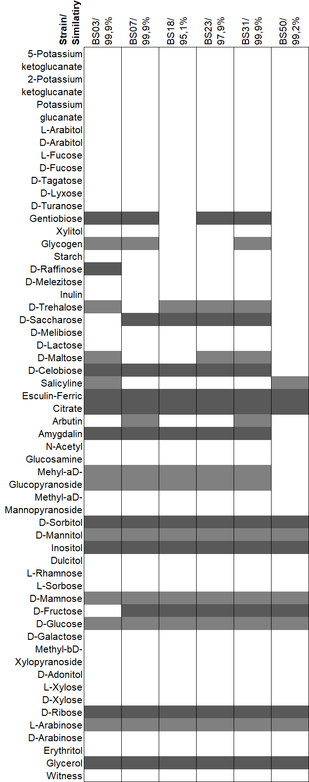

Figure 1. Heat map of the metabolic profile of 6 B. subtilis strains. Fermented carbohydrates are shown in grey.

The metabolic analysis carried out using API50CH / B galleries is shown in Figure 1. It can be observed that the strains that presented the greatest diversity in their metabolism were BS03 and BS31, with 18 and 19 fermented carbohydrates, respectively. BS50 and BS18 strains, on the other hand, presented lower metabolic diversity. The BS34 strain was cultivated in duplicate in the API galleries but showed inhibition at the moment of culture; therefore, the results obtained are omitted from the heat map. The percentages of similarity, according to the metabolic profile, were at least 95 %.

3.2 Preliminary assessment of LA production potential

Strains were assessed for their capacity to produce LA from glucose and are presented in Figure 2.

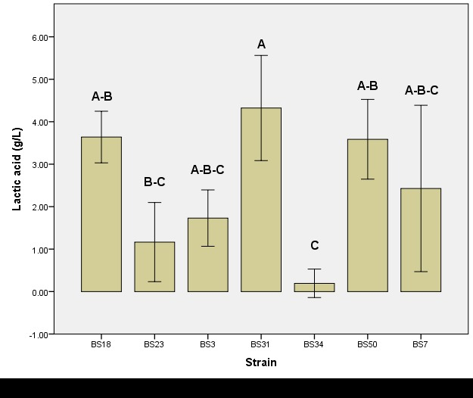

Figure 2. LA production of 7 Bacillus subtilis strains, under aerobic conditions.

The strains with the highest production rates were BS18 (3.64 g/L), BS31 (3.61 g/L) and BS50 (3.59 g/L). The mean of LA production of the BS31 strain is statistically different from those presented by the BS50 and BS18 strains, which do not present statistically significant differences between them. Strains BS03, BS34, BS07, BS23 produced lower LA concentrations. Therefore, due to their higher LA potential, and their ability to metabolize common sugars (i.e. glucose, fructose and sucrose, Fig. 3), strains BS18, BS31 and BS50 were chosen for subsequent experimentation.

3.3 Analysis of the effect of oxygen conditions on LA production

Once the strains with the highest productivity were identified, the effect of oxygen concentration on LA production was assessed. The results obtained from 72 h cultures under aerobic, anaerobic, and micro-aerobic conditions are shown in Figure 3. As a positive control, a *Lactobacillus spp.* (V1.1) was used. The aerobic culture presented a statistically higher LA production than anaerobic and micro-aerobic cultures. Strain 18 presented significant acid production under all culture conditions, unlike strains 31 and 50, which presented production only under aerobic and micro-aerobic cultures. There were no statistical differences between the strains at aerobic conditions, while under micro-aerobiosis, once again, strain 18 had the highest production level.

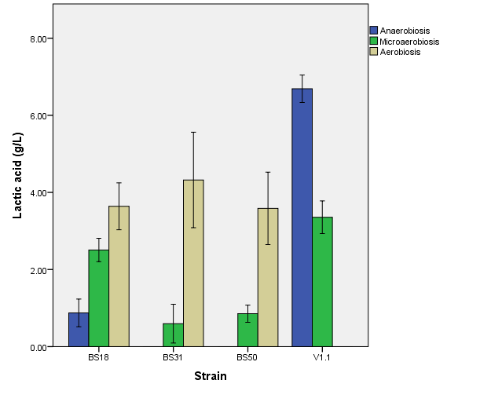

Figure 3. LA production from BS18, BS31 and BS50 strains under different oxygen concentrations.

The fermentation process begins with the formation of pyruvate through the Embden-Meyerhof pathway in which glucose is converted into 2 pyruvate molecules; After this step, the lactate dehydrogenase enzyme transforms pyruvate into LA generating energy in the form of NADH +. Although the absence of oxygen should stimulate the metabolic routes associated with anaerobic respiration, along with fermentative processes, this was not evidenced in this work. *B. subtilis* generally has a reduced ability to grow anaerobically in media that does not contain pyruvate or added amino acids. Results similar to those obtained in terms of a reduction in the production of LA in anaerobiosis were evidenced by Ohara & Yahata in 1996 and Romero-Garcia et al. in 2009. The BS18 strain was robust against changes in oxygen availability, and, although the difference between the average production between aerobiosis and micro aerobiosis is statistically significant, the decrease in the average production is small, becoming an interesting option to reduce future operating costs.

3.4 Kinetics of biomass change, glucose consumption and LA production

In all three strains, a production of LA concordant with glucose consumption is observed, as observed in Figure 4, beginning at 9 h of fermentation, and stabilizing at 24 h. The production of LA by the 3 strains is homogeneous and does not present any difference according to the statistical analysis. On the other hand, with respect to biomass production, an exponential growth can be observed between 9 and 27 h of culture. After this, during the 27 and 30 h, the strains presented a stage after which a second phase of cell growth continues. Differences in strain growth are not statistically relevant, with the exception of strain 18, in which a stage of cell death prior to the second growth stage is evidenced. The mean LA production obtained in BS18, B531 and BS50 was 4.66 g, 5.86 g and 4.38 g under aerobic conditions, respectively, consistent with that evidenced in other Wild type strains of *B. subtilis*. (Ohara & Yahata, 1996; Romero-García et al., 2009) Maximum LA production prior to 24 h of culture in all the strains. However, as the time intervals studied were wide, more analysis is required to establish the fermentation time required to reach equilibrium. As the theoretical values of LA production correspond to 1 g glucose / 1 g LA, efficiencies were between 21.9 % to 29.33 %.



Figure 4. Kinetics of biomass growth (dashed line), glucose consumption (grey line) and LA production (black line) for different B. subtilis strains: (a) BS18, (b) BS31, and (c) BS50.

Even though fermentations from glucose maintained significant LA concentrations, these are low to be considered within the framework of industrial application. However, analysis regarding the optimization of LA production by adding elements known for their ability to improve the fermentation process through *B.*  *subtilis*, such as pyruvate, and optimal concentrations of yeast extract, would be important to reach cost efficient conditions. Additionally, despite certain advantageous qualities identified in the strains, genetic improvement processes could be carried out to obtain yields close to those presented by lactobacillus species, while maintaining low costs in raw materials that work with *B.*  *subtilis*. High LA productions have been obtained from modified strains such as *Bacillus subtilis* MUR1, with which 159 g / L were reached (Gao et al., 2012).

4. Conclusions

Through this study, the identification of 6 *Bacillus subtilis* strains was achieved through the analysis of the biochemical profile allowed by the API50CH / B galleries. Molecular analysis by sequencing the 16S region did not allow an effective identification of the strains analyzed, being necessary other markers for the determination of species in *Bacillus subtilis*. Of these strains, the highest LA production rate was achieved under aerobic conditions, with LA concentrations of approximately 5 g / L, starting with a glucose concentration of 20 g/L. Despite the potential for LA production from these strains, improvements can be made through optimization of medium composition and genetic improvement.

**Funding**

The present work was funded through the Collaboration Grants Program at Universidad dad San Francisco de Quito.

References

Altschul SF, Gish W, Miller W, et al (1990) Basic local alignment search tool. Journal of Molecular Biology 215:403–410. doi: doi.org/10.1016/S0022-2836(05)80360-2

Ausubel F, Dracopoli NC, Wildermuth M (2011) Informatics for Molecular Biologists. Current Protocols in Molecular Bioly 96:1–3. doi: doi.org/10.1002/0471142727.mb1900s96

Borshchevskaya LN, Gordeeva TL, Kalinina AN, Sineokii SP (2016) Spectrophotometric determination of lactic acid. Journal of Analytical Chemistry 71:755–758. doi: doi.org/10.1134/S1061934816080037

Dubois M, Gilles KA, Hamilton JK, et al (1956) Colorimetric Method for Determination of Sugars and Related Substances. Analytical Chemistry 28:350–356. doi: doi.org/10.1021/ac60111a017

Gao T, Wong Y, Ng C, Ho K (2012) L-lactic acid production by *Bacillus subtilis* MUR1. Bioresource Technolgy 121:105–110. doi: doi.org/10.1016/j.biortech.2012.06.108

Harrison RG, Todd PW, Rudge SR, Petrides DP (2015) Bioprocess Design and Economics, 2nd edn. Oxford University Press, Oxford

Komesu A, Oliveira JAR de, Martins LH da S, et al (2017) Lactic Acid Production to Purification: A Review. BioResources 12:4364–4383. doi: doi.org/10.15376/biores.12.2.komesu

Nakamura LK (1989) Taxonomic relationship of black-pigmented *Bacillus subtilis* strains and a proposal for Bacillus atrophaeus sp. nov. International Journal of Systematic and Evolutionary Microbiology 39:295–300. doi: doi.org/10.1099/00207713-39-3-295

Nakamura LK, Roberts MS, Cohan FM (1999) Relationship of *Bacillus subtilis* clades associated with strains 168 and W23: A proposal for *Bacillus subtilis* subsp. subtilis subsp. nov. and *Bacillus subtilis* subsp. spizizenii subsp. nov. International Journal of Systematic and Evolutionary Microbiology 49:1211–1215. doi: doi.org/10.1099/00207713-49-3-1211

Nguyen CM, Kim JS, Hwang HJ, et al (2012) Production of l-lactic acid from a green microalga, Hydrodictyon reticulum, by Lactobacillus paracasei LA104 isolated from the traditional Korean food, makgeolli. Bioresource Technology 110:552–559. doi: doi.org/10.1016/j.biortech.2012.01.079

Ohara H, Yahata M (1996) L-lactic acid production by Bacillus sp. in Anaerobic and aerobic culture. Journal of Fermentation and Bioengineering 81:272–274. doi: doi.org/10.1016/0922-338X(96)82222-7

Orozco FG, Zuluaga F (2014) Lactic Acid Yield Using Different Bacterial Strains , Its Purification , and Polymerization through Ring-Opening Reactions. International Journal of Polymer Science 2014(4):1-7. doi: doi.org/10.1155/2014/365310

Palmisano MM, Nakamura LK, Duncan KE, et al (2001) *Bacillus sonorensis sp. nov*., a close relative of Bacillus licheniformis, isolated from soil in the Sonoran Desert Arizona. International Journal of Systematic and Evolutionary Microbiology 51:1671–1679. doi: doi.org/10.1099/00207713-51-5-1671

Priest FG, Goodfellow M, Shute LA, Berkeley RCW (1982) Bacillus amyloliquefaciens sp. nov. norn. rev. International Journal of Systematic and Evolutionary Microbiology 37:69–71. doi: doi.org/10.1099/00207713-37-1-69

Rhee MS, Wei L, Sawhney N, et al (2016) Metabolic potential of *Bacillus subtilis* 168 for the direct conversion of xylans to fermentation products. Applied Microbiology Biotechnology 100:1501–1510. doi: doi.org/10.1007/s00253-015-7124-x

Roberts MS, Nakamura LK, Cohan FM (1996) *Bacillus vallismortis* sp. nov., a close relative of *Bacillus subtilis*, Isolated from Soil in Death Valley, California. International Journal of Systematic and Evolutionary Microbiology 46(2):470–475. doi: doi.org/10.1099/00207713-46-2-470

Roberts MS, Nakamura LK, Cohan FM (1994) *Bacillus mojavensis* sp. nov., Distinguishable from *Bacillus subtilis* by sexual isolation, divergence in DNA sequence, and differences in fatty acid composition. International Journal of Systematic and Evolutionary Microbiology 44:256–264. doi: doi.org/10.1099/00207713-44-2-256

Romero-Garcia S, Hernández-Bustos C, Merino E, et al (2009) Homolactic fermentation from glucose and cellobiose using *Bacillus subtilis*. Microbial Cell Factories 8:1–8. doi: doi.org/10.1186/1475-2859-8-23

Silva HSA, Tozzi JPL, Terrasan CRF, Bettiol W (2012) Endophytic microorganisms from coffee tissues as plant growth promoters and biocontrol agents of coffee leaf rust. Biological Control 63:62–67. doi: doi.org/10.1016/j.biocontrol.2012.06.005

Skerman VBD, McGowan V, Sneath PHA (1980) Approved lists of bacterial names. International Journal of Systematic and Evolutionary Microbiology 30:225–420. doi: doi.org/10.1099/00207713-30-1-225

Smith NR, Gibson T, Gordon RE, Sneath PH (1964) Type Cultures and Proposed Neotype Cultures of Some Species in the Genus *Bacillus*. Microbiology 34:269–272. doi: doi.org/10.1099/00221287-34-2-269